**Graph data**

When we have graph data for ex: social graph in fb then we have to do graph featurization.

In below ex. Ui are users and edges are friendship.

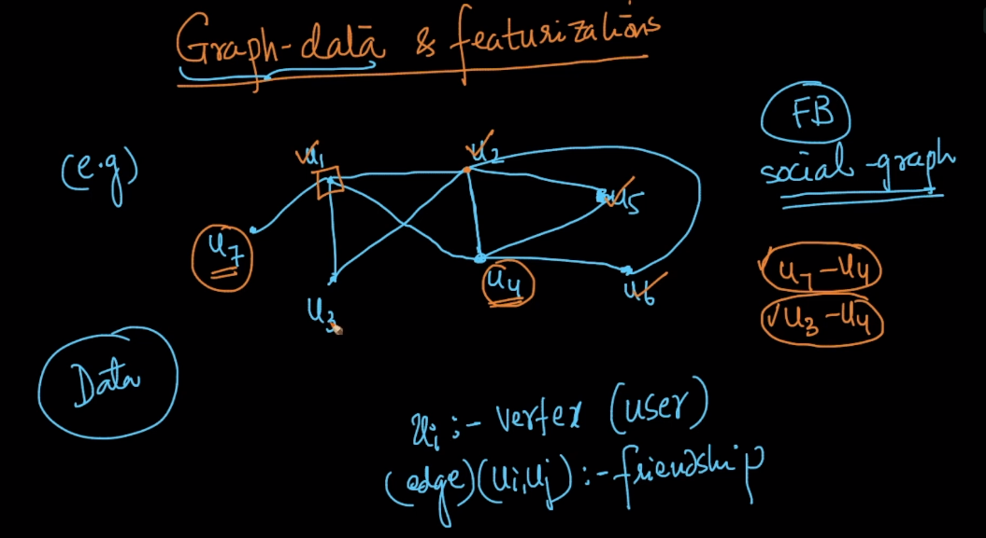

For this featurization we find mutual friends suppose we want to find mutual friend of user 4 u4 then we check it through graph and find that u7 and u3 are mutual friends of u4

So in this way we create a feature for graph data

Like

F1 : number of mutual friends

F2: path b/w ui and uj

